STAIRCASE SECTIONAL PLAN

we can use the sectional plan of the staircase used in the building planning. For that,

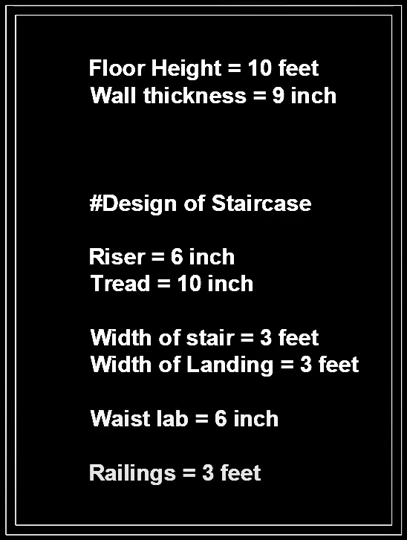

First, we need to on the first four things, like dynamic input, ortho mode, and object snap tracking. Then we need to set the unit using the command ‘UN’. Type is set into the engineering, then the precision needs to be set to ‘0.0000’. units to be scales is set to be inserted content is set to be inches. The details are given above.

Mainly you need to remember that the distance of the stairs can vary to the floor height and the number of steps. Like in the above table we can see that the floor height is 10 feet and the riser is 6” each. So, if we divide the riser by the floor height then we can find the number of steps. For example:

10 feet = (10 x 12) inches = 120 inches. Which can be divide by 20 steps. (10 steps middle, then u turn then again 10 steps. So total of 20 steps) we will get 6 inches per riser.

Or you can do that riser multiplied by steps = floor height

We need to remember that as per the IS code, then width of the stairs is need to be equal to the width of the landing.

For any random staircase, we need to make the staircase plan first then we can make the elevation. Here a random staircase is provided first then the elevation of the stair of earlier making plan will be executed.

For making a stair from the above image, first, we need to make a line (command ‘L’), then make a line of 3’ then escape(esc) which will be the width of the stair. Make to thick the line (here use 0.3mm). to check the thickness in the plan, make sure that your linewidth is enabled. Then offset the line into tread distance (here 10 inches given). You can provide more than the given tread length minimum distance is 10 inches. Here we will offset 10 times for 10 steps. Then copy them, select the lower right-side point, and then copy it above (distance 3’6”). Then in the middle portion make a rectangle, then make 2 2-inch offsets for railings (this offset will be the outer side.) you can make 1” or 1.5” offset for railings.

Now we need to make landings on both sides. For that, take a line, then from the upper left corner (which will be upper line on the left-most line) and make a 3’ line horizontally, then make a line of 6”6’ vertically then close the line.

Again, make the same on the other side. Then make 9” wall on the outer side. Then provide a door.

Your staircase will be ready.

**SECTIONAL ELEVATION**

For making a sectional elevation of a staircase, we already have a stair from the previous plan which is given below.

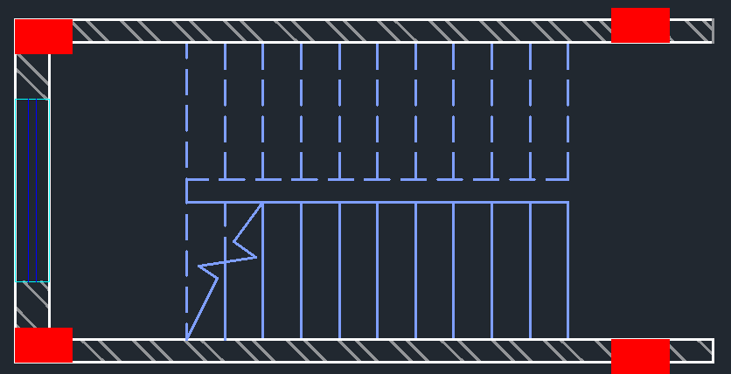

Here we will need the projection line, (we can also use the construction line). To take the projection line, we can press the command (RAY) which enables the projection line. Then first point will be the corner (upper) point so click on the corner then click on which side you want to make a line like this.

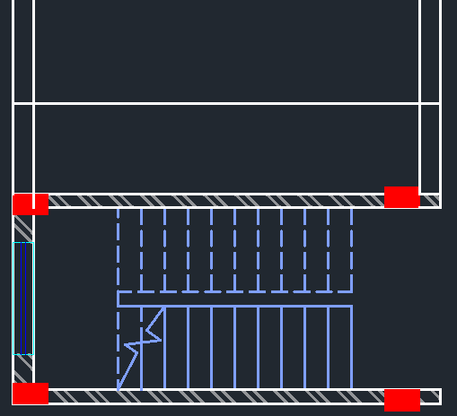

Then make a horizontal line from which you want to make your sectional plan like the above. Then provide a plinth height from 2 to 3 feet (here we are giving 2.5 feet). Then take the offset of floor height which is 10 feet (see elevation plan).

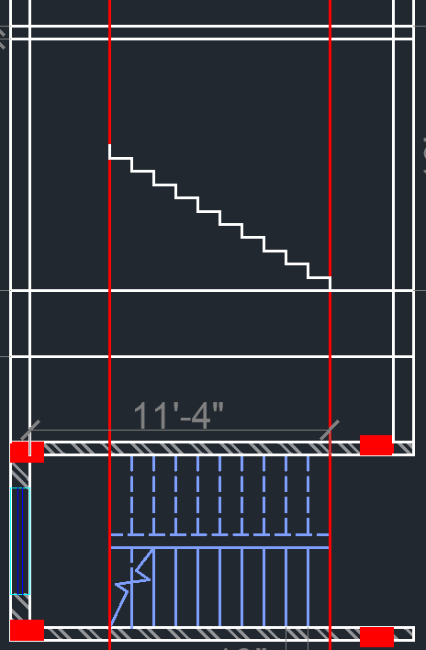

Then we need a complete line from where the stairs are completed like this.

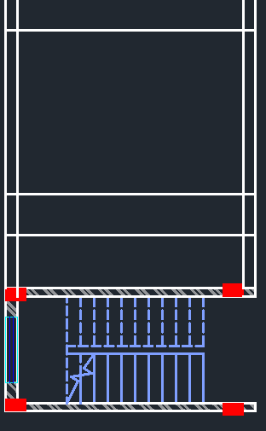

Now we have to provide the slab of 6” from the upper line to the lower side like this.

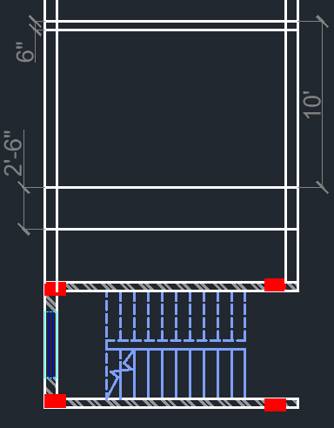

The above 6-inch slab will be useful for landing of staircase. Now we have to take the projection line of the stairs landing from the stair plan provided below like this.

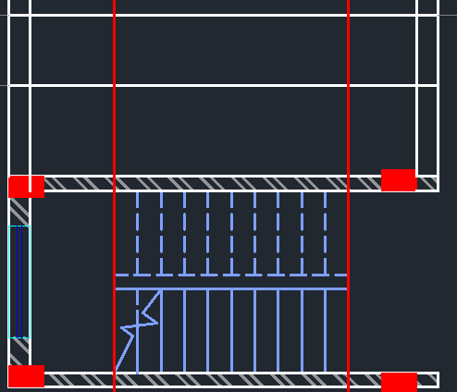

So, between two red line the steps will be provided, and the two sides are given for landings.

Now for making stairs, we need to take PL for polyline, from the first red line (which is given on the door side) make a 6” vertical line, then 10” horizontal line for tread. then make an escape by using esc (or you can make all the stairs which will be more time-consuming). Then copy the stair and paste it 10 times (the last stair can exceed the red line) like this.

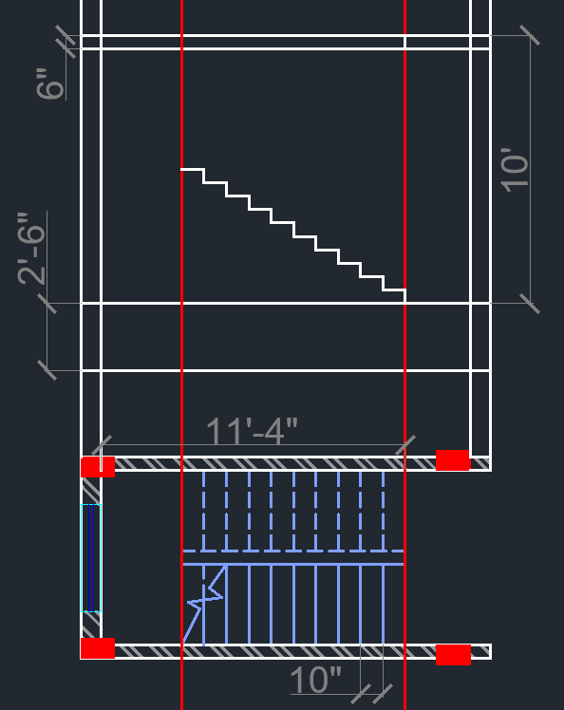

Then the last line needs to be trimmed like this (the last line will be the red line which shows above). After that, make a line from the stair ending to last line (last left line). Then mirror the stairs above like this

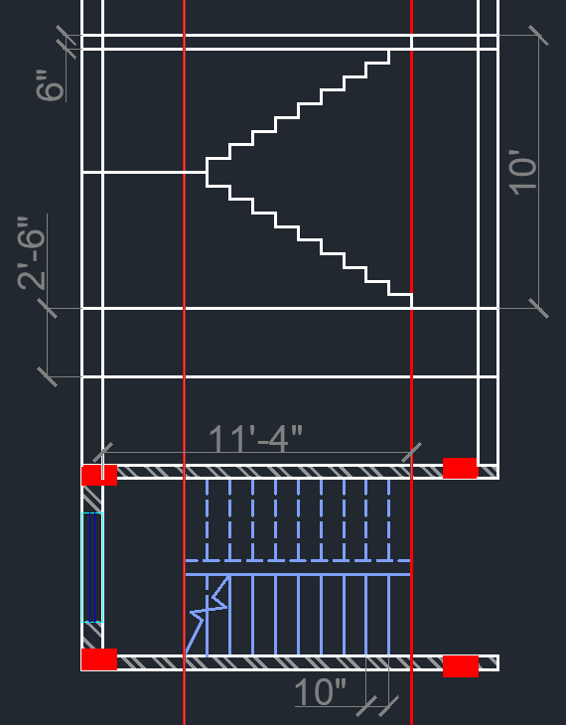

It is mandatory that in 20 steps the entire floor should be covered. Sometimes we need to cover the entire floor in 18 steps, or 16 steps, then the steps need to be lesser and the height of the riser needs to be increased. But one thing is important the height of the riser should not be more than 7” otherwise climbing the stairs will be very difficult. So 6”-7” is comfortable but the 8” stairs are uncomfortable.

Now we need to make a waist slab, waist slab is the thickness of the slab which is provided below the slab. For making the waist slab, make a line first like this

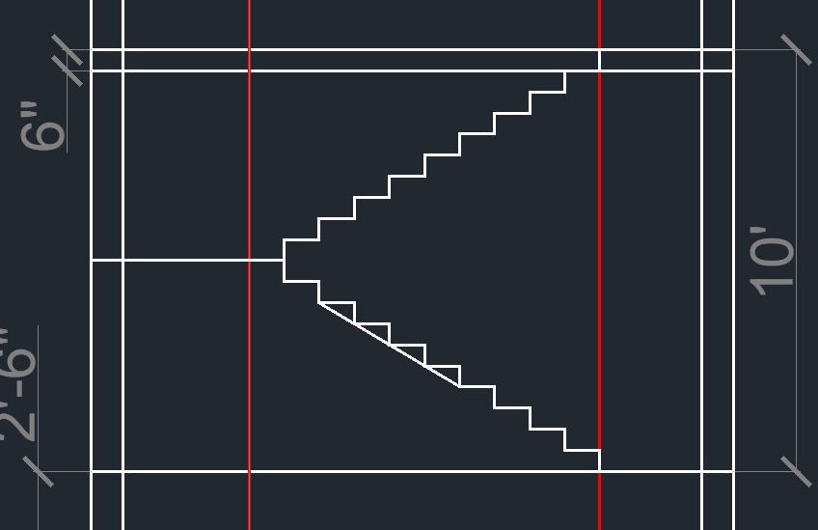

Then make an offset of 6” which is the depth of waist slab, then delete the previous line like this

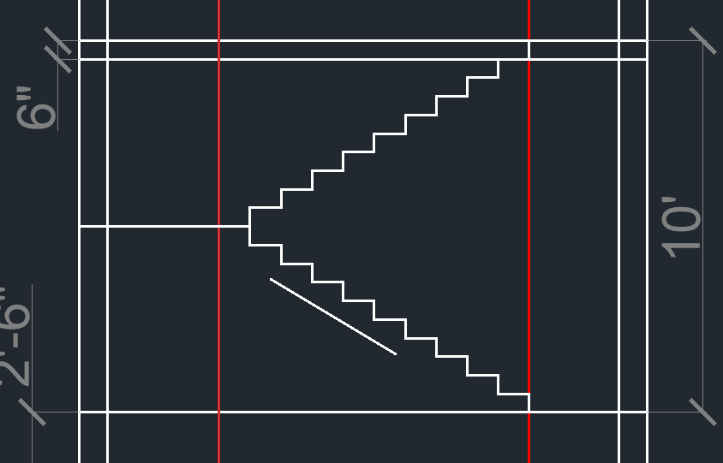

Make the same thing in the upper stair like this

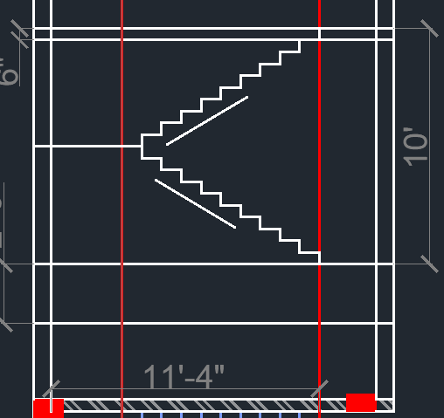

Then extend the lines by using EX then press double enter. Then extend the lines like this

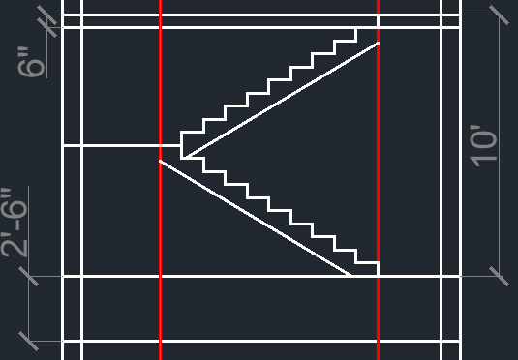

Now we need to make the thickness of the landing so we can make the thickness by using offset of 6” like this

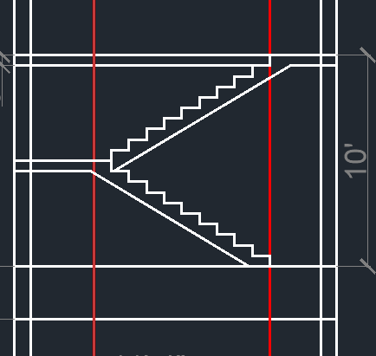



Now trim the extra line (which is given in red mark, and don’t trim the red line, see planning for proper understanding) like this. Now we can delete the upper line (which was the offset of 6” for making the slab of roof, and we can also delete the roof line also).



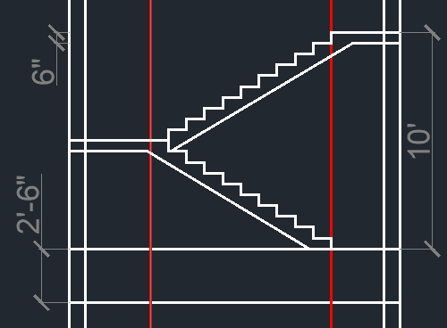



We need to provide a wall beam. For that taking an offset of 12”, and providing the wall beam from the line marked above like this

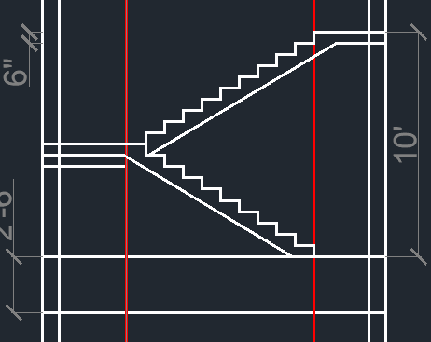

Then trim the extra line from the both side (we need to provide wall beam at middle and upper wall). The final drawing after trimming will look like this.

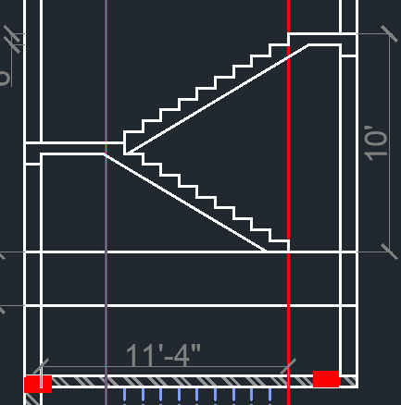



Now we can remove the projection lines (red lines). We can remove these lines. In the above red-marked portion, we need to make another wall beam so taking an offset of 1’ then trim the middle portion lines. Making another line in here of 6” which defines the slab like this

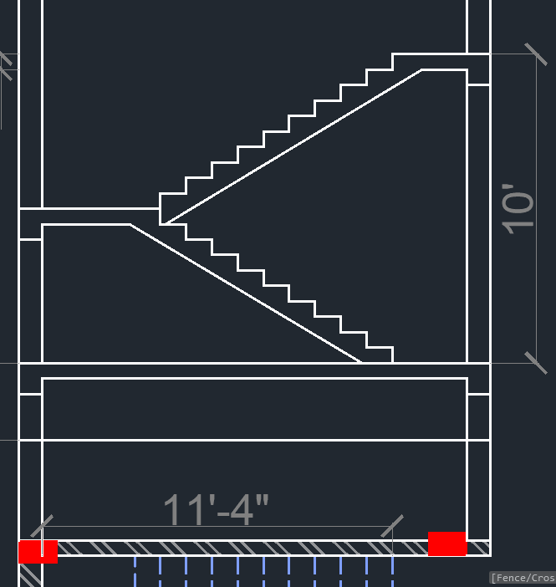

Now delete the projection lines.

Now according to the drawing, we need to make a window. For that, we need to make an offset of 3’ from the landing for see height, then a 4’ offset for the window, and then 6” for the lintel. Then trim the lines. After making these lines, it will look like this

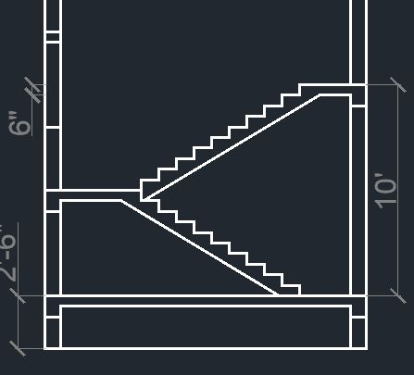



Now we can make a chajja for the lintel portion. For that, take a line of 1” (you can use longer chajja for that you can take 1.5’). then on the above potion taking 4”, then close the line. After making it will look like this.

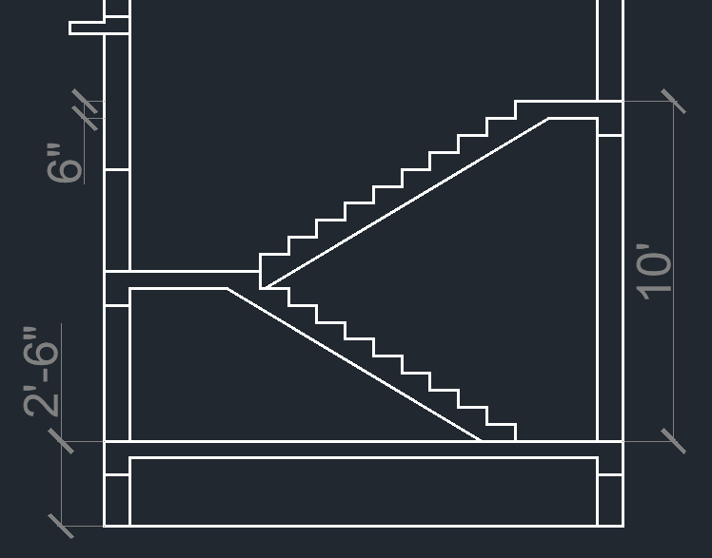

Also you can make some slanted (downward) like this



Now we can make the window below the chajja portion. For that, you can make a line in the middle portion like this



If doors available in your drawing then you can make a door. In the planning (another), here are a door available which is given below.

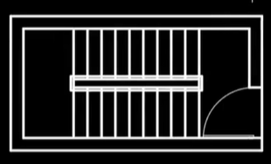

For that, take an offset of 7’ for the door, then 6” offset for lintel beam, then trim the remaining line. It will look like this

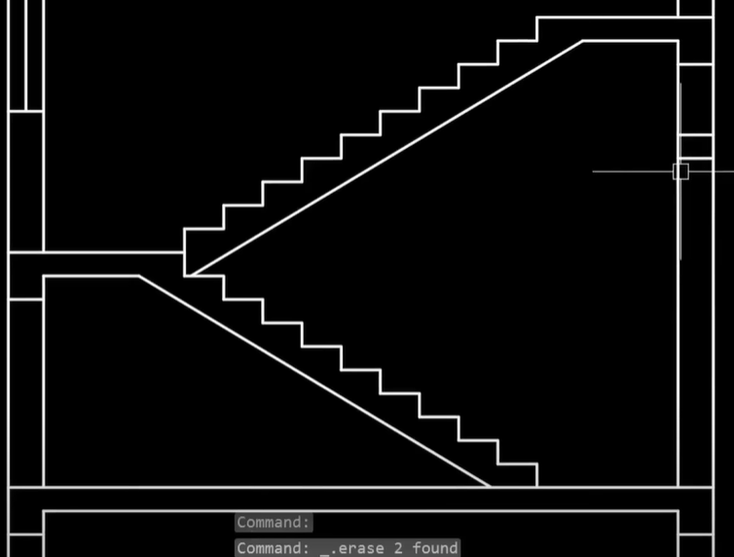

And make a line in the middle portion

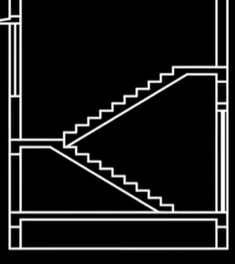

In the planning of staircase, you need to show the section line like below

Now we are making double floor so we need to copy the entire staircase and paste it above like this

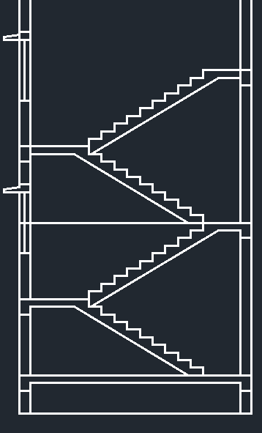

As you can see some extra things come for copying, like the line come in window which we need to remove. And some beam line also needs to trim. Now we need a door for terrace. For that, we can make a door in the above like this

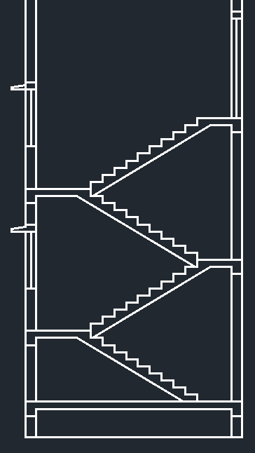

Now we need to make a headroom, for that, we need to remove the 6” line (above the door line). We need to provide a slab for the headroom. We can take a height of more than 7’ (from landing). So, we are taking 8’ from the landing for the headroom. Then extend fully like this.

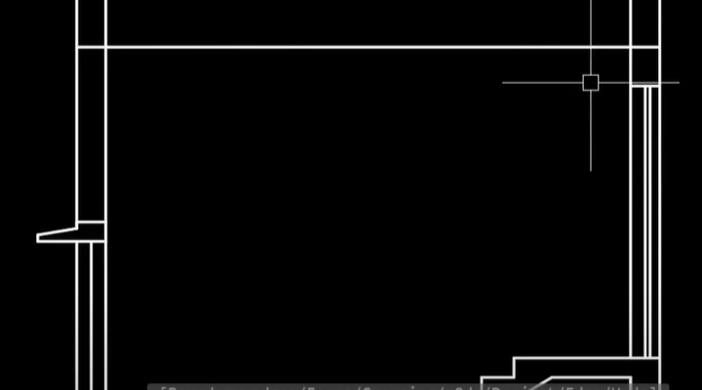

Then make 6” thickness for the slab (offset of 6” in the lower side like this).



After that we need to provide a beam also, for that we can take offset of above line and making 1’ offset in the below, then unnecessary lines like this.

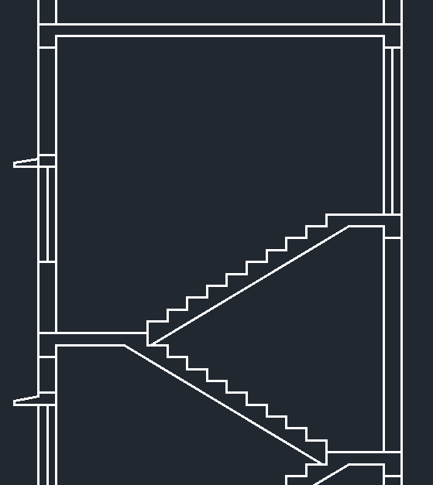

Now the above line can be deleted because we don’t need it anymore

Now we need to show chajja for headroom, for that taking a line of 1’ from the top above point, then 6” to the lower portion, then mirror it for another side like this.

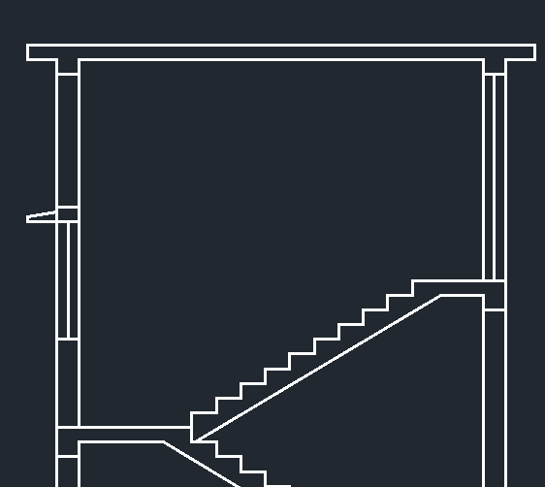

The main portion drawing is completed, now we need to make details like concrete hatching, wall hatching, annotation, text, etc. for the drawing.

We will use the hatching ‘ANSI31’ for the wall and make all the hatching on the wall portion. But one thing needs to be remembered if we use hatching with a line width of 0.30mm then the drawing won’t be so good to watch so we need to lower the linewidth. After concrete hatching, it will look like this

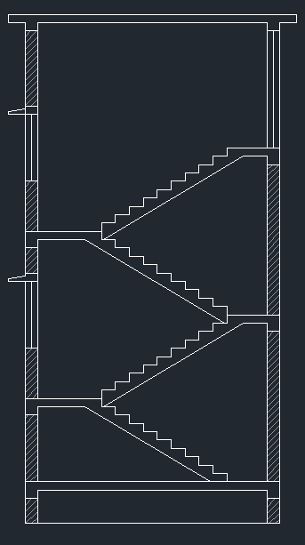

Now we need to make concrete hatching on the stairs. For that, we can take the ‘AR-CONC’ then applying the concrete hatching.

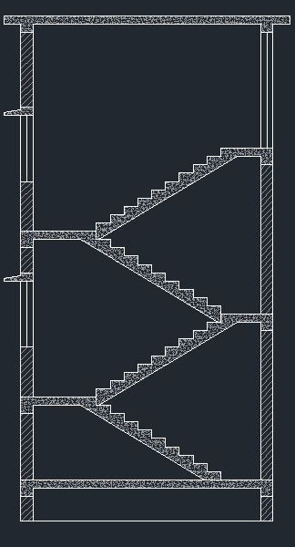

Now we need to make the railings for the stairs which we show in the planning of staircase. For that, making a line of 3’ like this

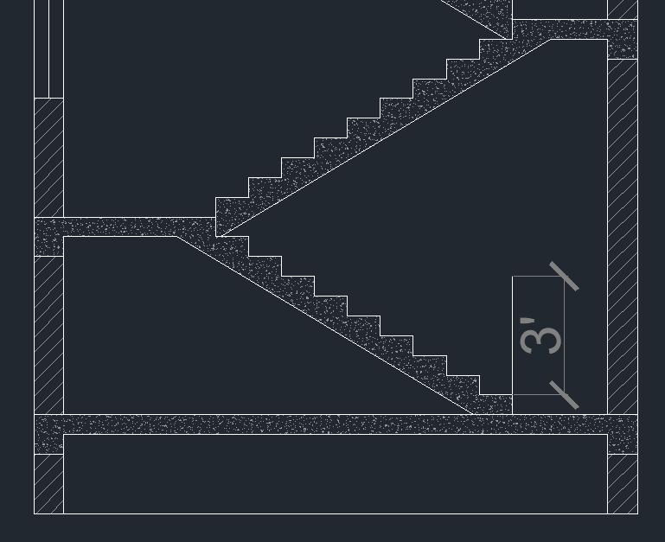

And making another line in other direction then joining those two lines like this

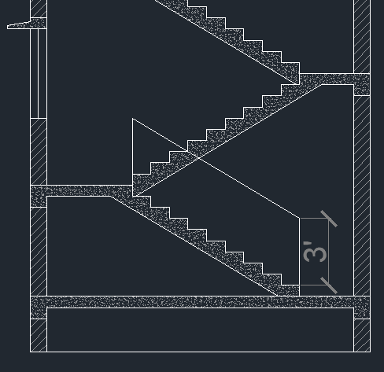

These lines needs to join together, so select those 3 lines, then press ‘J’ for join.

After making all the railings, it will looks like this

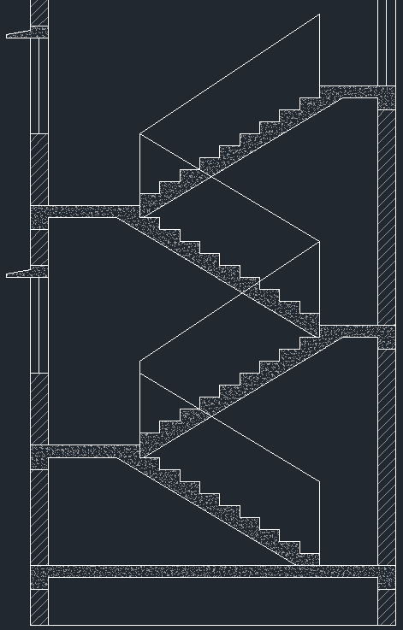

The section line needs to make in hidden. So changing the line to hidden line. Then we need to define the arrow, so we can use the leader from the ribbon bar (if problem occurs, then we can xplode the arrow).

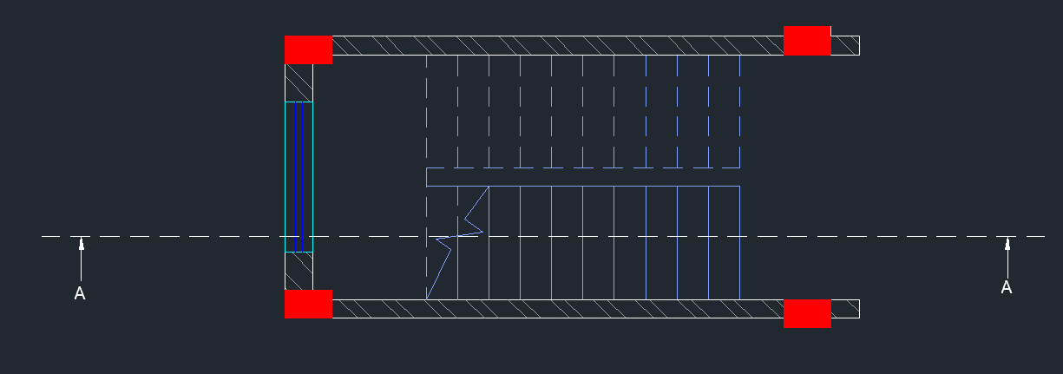

Now name the section view.

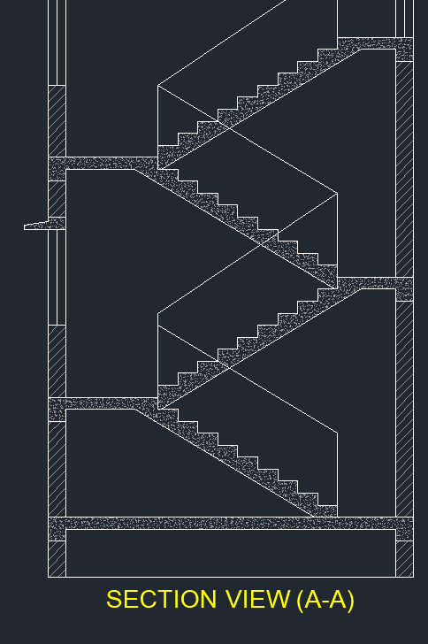

Now we need to provide some information in the sectional plan which is given below.

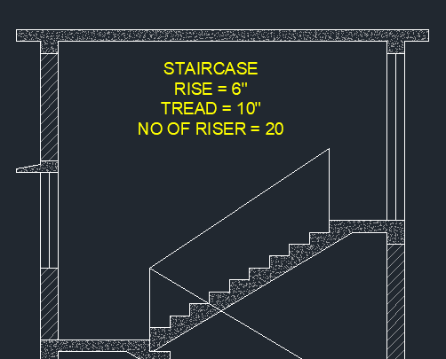

Providing dimensions

